

Iron Horse No. 2010

Roper Whitney PX1010-R

Mechanical Shear

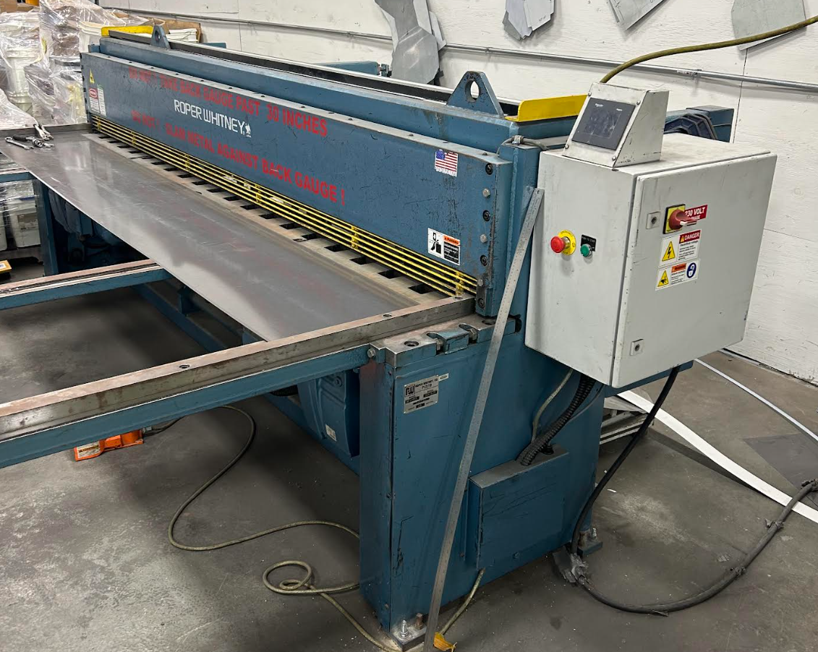
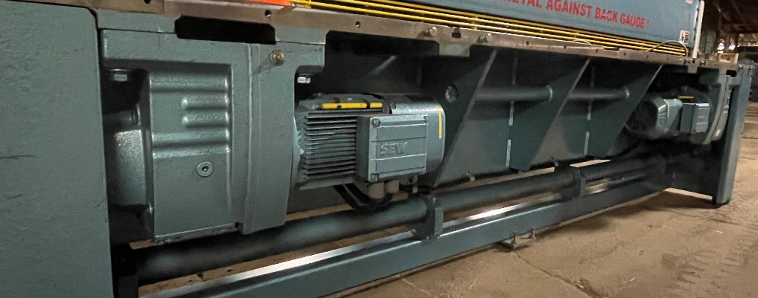
The dual motor design, of the PX Series, produces accurate distortion free shearing while minimizing material twist

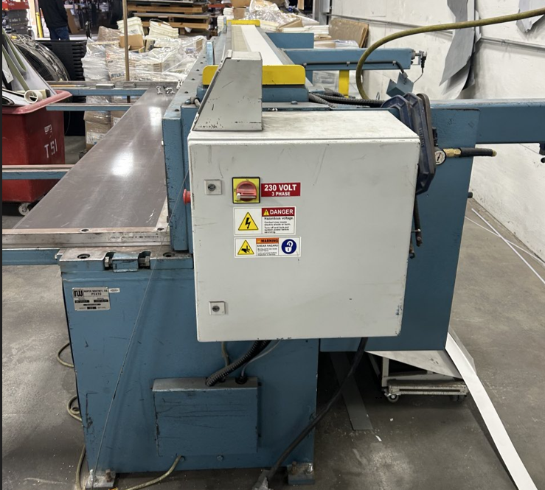 | 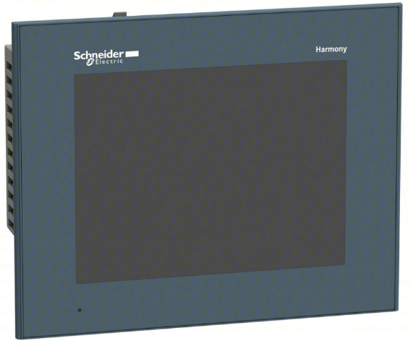  A Schneider digital readout is standard for this system

PEXTO PX Series mechanical shears utilize a low maintenance design, coupled with an array of standard features for an attractive combination of high value and solid performance. PX1010 shears incorporate a dual motor design. The dual motor design, of the PX Series, produces accurate distortion free shearing while minimizing material twist. The system is capable of 45 strokes per minute. PX shears are ideal for high volume applications. The PX series also includes the unique powered 24? back gauge system. A digital readout is standard for this system. The ball screw-driven back gauge provides quick, accurate cuts. PX Series shears standard features include four-edge, high carbon, high chrome blades, independent, self-leveling hold down feet with neoprene inserts, single, continuous and jog stroke cycles, motor reverse switch, precision-machined T-Slotted table. The table also has a hand well with dual inch/metric inlaid bed scales. PX shears incorporates non-metallic ram gibs and low maintenance Garlock bearings.

Powered Back gauge

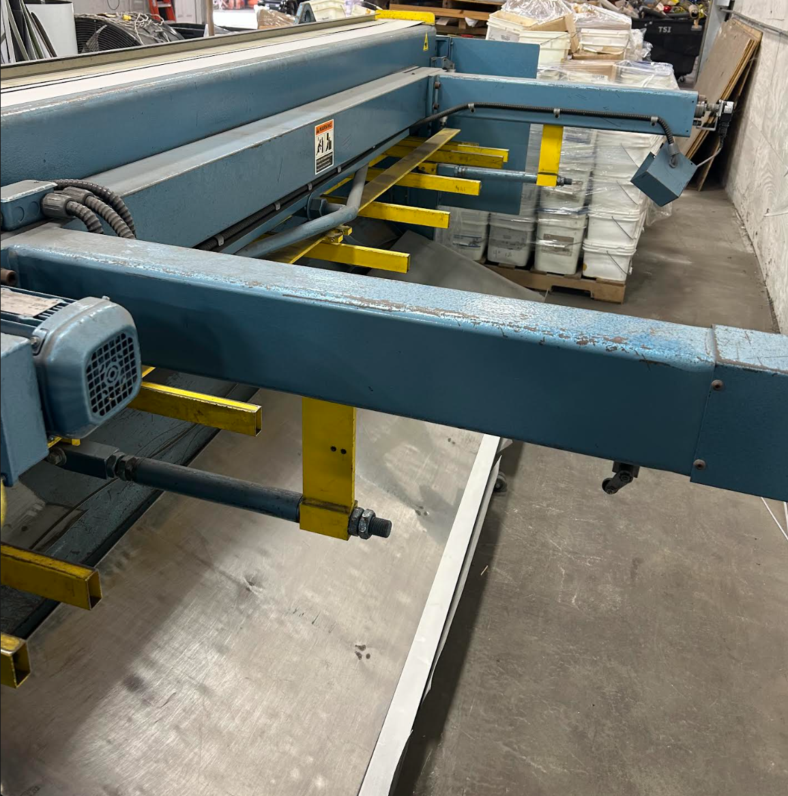

support arms

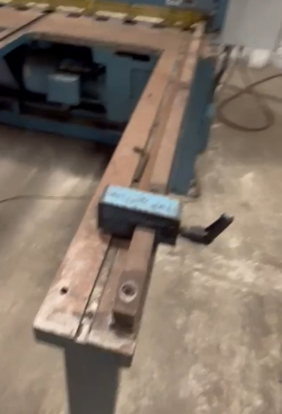
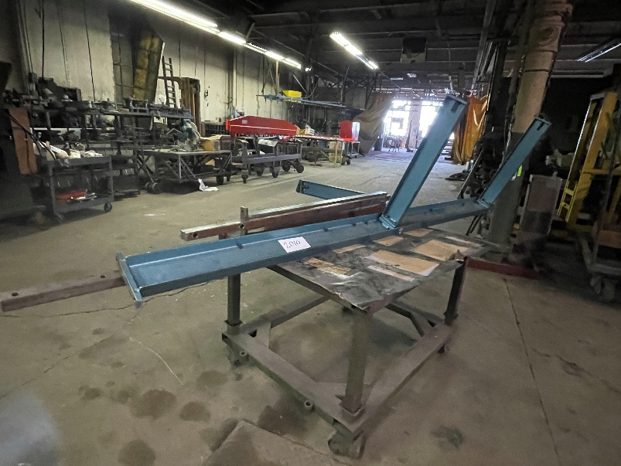
To enhance productivity, optional equipment available for the machine includes: five or ten-foot squaring arm, t-slotted front support arms, light beam and protractor attachments. Please contact Roper Whitney for a complete listing of optional equipment. The PX series can be delivered in a ÒPro Package” configuration. The Pro Package includes: Five Foot Squaring Arm, Two Front Support Arms, ÒR” Rear Drop Air Operated Sheet Support System and the 24? Front Operated Powered Back gauge with Digital Readout. For more details, please contact Roper Whitney.
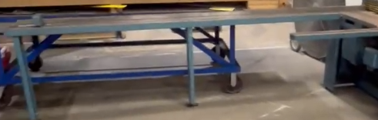

Specifications

- Maximum shearing capacity, mild steel rated materials at 80,000 tensile/ 44,000 yield: 10 ga/ 3,5 mm
- Maximum shearing capacity, stainless steel rated materials at 90,000 tensile/ 55,000 yield: 14 ga/ 2,0 mm
- Maximum cutting length: 121 in/ 3074 mm
- Back gauge range: 30 in/ 762 mm
- Strokes per minute: 45
- Number of hold down feet: 16
- Drive motor 230/460v, 3 phase, 60 Hz: 7.5 hp x 2
- Back gauge motor 230/460v, 3 phase, 60 Hz (if equipped): 1/4 hp
- Floor space, gauges in position: 145 x 78 x 60 in
- Dimensions: 48 x 72 x 144 in
- Weight: 9200 lbs.

Video can be seen on:
ironhorseinnovationsllc.com

